**OpenGL Documentation**

1. [OpenGL Video Tutorial - Home (videotutorialsrock.com)](https://www.videotutorialsrock.com/)
2. [LearnOpenGL - OpenGL](https://learnopengl.com/Getting-started/OpenGL)
3. OpenGL is mainly considered an API (an Application Programming Interface) that provides us with a large set of functions that we can use to manipulate graphics and images.
4. Math for graphics: [Vectors (mathsisfun.com)](https://www.mathsisfun.com/algebra/vectors.html)
5. A translation process moves every point a constant distance in a specified direction. It can be described as a rigid motion. A translation can also be interpreted as the addition of a constant vector to every point, or as shifting the origin of the coordinate system.
6. Suppose, If point (X, Y) is to be translated by amount Dx and Dy to a new location (X’, Y’) then new coordinates can be obtained by adding Dx to X and Dy to Y as: X' = Dx + X Y' = Dy + Y
7. Point translation: just add translation factor with original point
8. Line translation: just add translation factor with start and end point
9. Rectangle translation: just add translation factor with top left and right bottom
10. 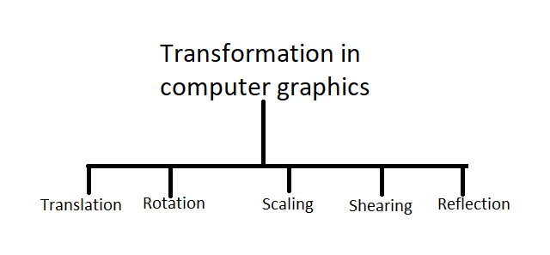
11. GLFW: [An OpenGL library | GLFW](https://www.glfw.org/) : Contains dll and .h files for visual studio uses
12. Dynamic linking: Copy the GLFW folder to the .sln directory
13. Cut the DLL to the directory of .cpp, .h files
14. Then, in the C/C++ general: $(SolutionDir)\GLFW\include; Make “all configuration” in properties
15. $(SolutionDir) will dynamically link, path on other PC don’t need to have same directory
16. Glew: [GLEW: The OpenGL Extension Wrangler Library (sourceforge.net)](https://glew.sourceforge.net/)
17. GLM: [OpenGL Mathematics (g-truc.net)](https://glm.g-truc.net/0.9.9/index.html)
18. OpenGL Mathematics (GLM) is a header only C++ mathematics library for graphics software based on the OpenGL Shading Language (GLSL) specifications.
19. There is no lib, we just need to include it in VS
20. For image load and texture: [SpartanJ/SOIL2: SOIL2 is a tiny C library used primarily for uploading textures into OpenGL. (github.com)](https://github.com/SpartanJ/soil2)
21. [Releases · premake/premake-core (github.com)](https://github.com/premake/premake-core/releases)
22. Download these 02
23. Then copy the premake5.exe to SOIL folder
24. Then in cmd “premake5.exe vs 2022”
25. Then go to make folder, windows under SOIL directory
26. Open soil2.sln
27. Build soil2-static-lib for debug and release
28. Lib and include files will appear in soil folder
29. CPU drawing -> GPU -> Vertex Shader -> Fragment -> Pixel in screen. **How drawing from CPU show by GPU?**
30. Glsl is not recognized by VS
31. Install glsl: [GLSL language integration (for VS2022) (vsixgallery.com)](https://www.vsixgallery.com/extension/999396e8-1400-4b23-ae9e-17e823006a12)